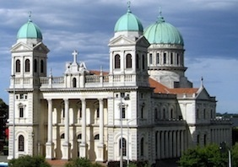
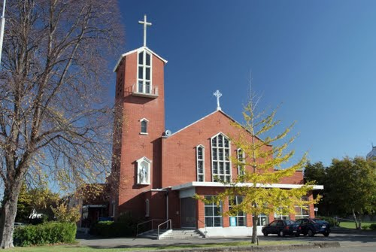

CBS Music
Cathedral of the
Blessed Sacrament Music
Don Whelan Musical Director
2 Carruthers St, Christchurch 8041, NZ
phone 64 3 358 5873 mobile 027 458 5873
don.whelan@xtra.co.nz
www.cathedral.org.nz

Catholic Pro-Cathedral
Cathedral of the Blessed Sacrament

Messiah
Handel’s Messiah will be presented by CBS Music in St Mary’s Pro-Cathedral, 373 Manchester St., on Sunday, December 6, 2026, at 1.30 pm.

Soprano soloist will be Emily-Jane Stockman, who has sung with the CBS Choir this year as soprano soloist for a newly established Youth Leader programme, which supports financially a quartet of young professional singers. Next year, Emily-Jane will study in Auckland for a master’s degree, providing an opportunity for young singers based in Christchurch to experience the varied repertoire and solo opportunities of the CBS programme. Alto soloist will be Jessica Adams, director of the Cecilian Singers, who sing annually at the Pro-Cathedral, where the repertoire includes a Festive Mass written by Jessica’s father, Dr John Wells.

Regular Messiah soloists will be Wally Enright, Ken Joblin, and Chris Whelan. The Cathedral Orchestra will be led by Natalia M. Lomeiko, with continuo Janet Cubey and Peter Low. Don Whelan will direct. Admission is $30 and $25, with Eftpos available.

This annual performance has continued to attract a substantial audience. Messiah proved a popular choice on the group’s first four European tours, and concerts throughout the Americas. While awaiting a future cathedral building. the spacious and resonant Catholic Pro-Cathedral is proving an excellent concert venue and temporary home for the cathedral music programme. The adjacent CBS Music Centre provides a substantial second auditorium, with very good acoustics and dedicated lighting, used for rehearsals and chamber music concerts.

At this year’s Christmas Midnight Mass, the CBS Choir and Orchestra will mark the bicentennial of Carl Maria von Weber with his spectacular Jubilee Mass in G, and the preceding vigil, beginning at 10.30 pm, will contain the usual congregational carols.

Next year, CBS Music continues its popular Lunch Plus Wednesday At One recital series, the Bach St John Passion at 8 pm on Good Friday, and another Christmas Messiah at 1.30 pm on Sunday, 5 December. On February 7 Strings on Sunday will feature a Bach Brandenburg Concerto and concertos for cello and organ by Vivaldi and Handel. Further concerts are planned for 7 March, 2 May and 4 July. The annual Haydn concert will be on 5 September, and a memorial concert will mark All Hallows Eve on 31 October. The CBS musical year will conclude with a performance of Beethoven’s Mass in C at next year’s Christmas Midnight Mass.

New members are welcome to join the cathedral choir, which rehearses on Wednesday evenings at 7.30 pm in the CBS Music Centre. Sight reading ability is expected. Those interested should contact the musical director, Don Whelan, ph. 358 5873.

