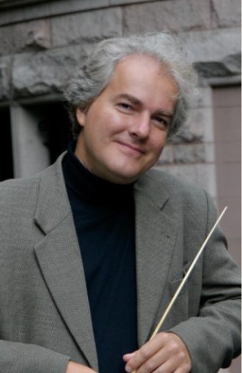
Piano Recital - Friday 20th March
An Afternoon with Eugene Albulescu – Saturday 21st March
The Piano House, 283 Riccarton Road
Eugene Albulescu is an award winning performer who combines a blazing technique with the artistic integrity and originality to express musical emotions at their most personal level. His work as a conductor, soloist and recording artist spans four continents and over four decades.

At age twelve, Albulescu won First prize in Romania’s National Music Competition, and at sixteen he was the youngest competitor and winner of the New Zealand Symphony Orchestra Young Musicians Competition.

His emergence on the international scene came in 1994, when his debut recording (Albulescu Plays Liszt, MANU1446) earned him the Grand Prix du Disque Liszt, awarded for the best Liszt recording of the year, adding Albulescu’s name to that of legendary recipients such as Horowitz and Brendel.

Albulescu has worked as conductor and soloist with numerous major orchestras including the New Zealand Symphony, the Romanian National George Enescu Philharmonic, the New York Chamber Orchestra, the Manukau Symphony Orchestra, and Christchurch Symphony. He toured the US with the Barbizon Chamber Orchestra and later led two US tours as music director with the French Chamber Orchestra.

Mr. Albulescu has also recorded solo piano sessions for South African Broadcasting Corporation, as well as Radio New Zealand, and in the US has been a featured artist on NPR’s Performance Today. His most recent release on the AMP label, featuring performances of Beethoven’s Piano Concertos 1 and 5, has earned significant acclaim and unanimously positive critical reviews.

Albulescu’s outreach in over one hundred US high schools has been significant, and his program “Inside the Piano” linking technology and creativity earned him coverage from the major media, including articles in the Washington Post and Philadelphia Inquirer, as well as the cover of Clavier Magazine. Some of his notable performances include two invitations to perform at the White House in 1996 and 1999, as well as performing at the 2002 Winter Olympics in Salt Lake City. Albulescu has twice been awarded the Steinway Teacher of the Year Award, in 2017 and 2022, and was inducted into the Steinway Teacher Hall of Fame in 2023.

Albulescu started his piano studies in Romania at age six, at the Enescu Music School in Bucharest. His family moved to New Zealand in 1984 to escape Romania’s Communist regime. He completed his musical studies with Edward Auer at Indiana University where, at nineteen, he was the youngest person ever to teach as an assistant instructor. A Steinway Artist since 2005, he currently is the Ulrich Professor of Music at Lehigh University in the Music Department.
Piano Recital
7.30 Friday 20th March
The Piano House, 283 Riccarton Road,
$40 IRMTNZ Members
$60 Non IRMTNZ Members
$20 Student
Ticket only via google form

Programme
Eugene Albulescu, piano
English Suite No. 2 in A Minor, BWV 807 Johann Sebastian Bach
Prélude (1685–1750)
Allemande
Courante
Sarabande
Bourée I, II
Gigue

Sonata in E-Flat Major, Hob. XVI/52 Joseph Haydn Allegro (1732–1809)
Adagio
Finale: Presto
Intermission

Sonata in E-Flat Major, K. 282 Wolfgang Amadeus Mozart Adagio (1756–1791)
Menuetto I, Menuetto II
Allegro

Andante in F Major WoO. 57 Ludwig van Beethoven
(1770–1827)

Étude Op. 25 No. 1 in A-Flat Major Frédéric Chopin
Ballade No. 1 op. 23 in G Minor (1810–1849)

Saturday March 21st
Session 1 – Memorisation tips and techniques
Session 2 – Piano Masterclass
The Piano House Riccarton Road
1.30pm - 2.30 Session 1: Memorisation tips and techniques
2.30 – 3.00: Afternoon tea
3.00 – 4.30: Masterclass
Masterclass Participants
We are looking for 3 senior students to take part in the Masterclass with Eugene Albulescu. If you have a student who you feel may be suitable and would benefit from the experience, please contact Janey Seed by email: janey_seed@xtra.co.nz no later than February 17th.
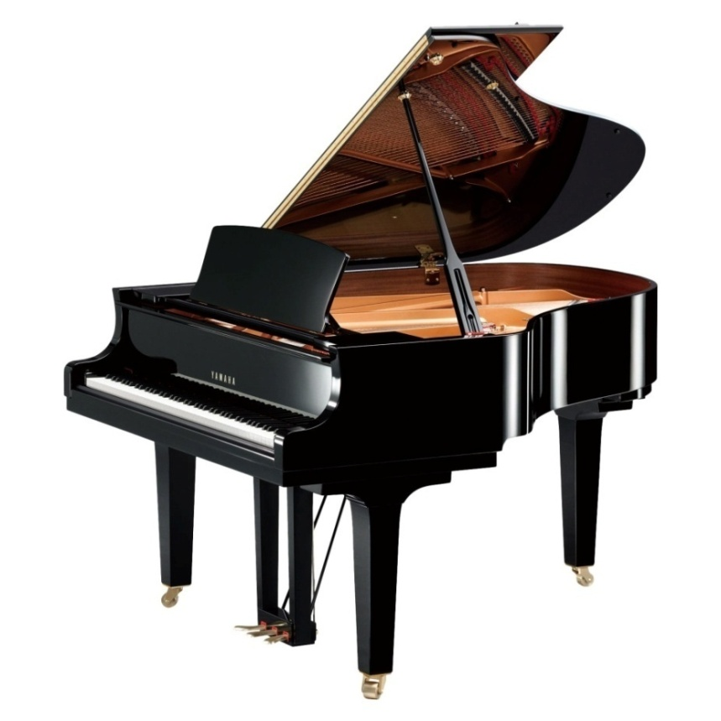
$35 IRMT members
$45 Non members
$20 Students (including Masterclass participants)

Special Deal for IRMTNZ Members
Both Friday and Saturday $70

Eugene Albulescu Form

