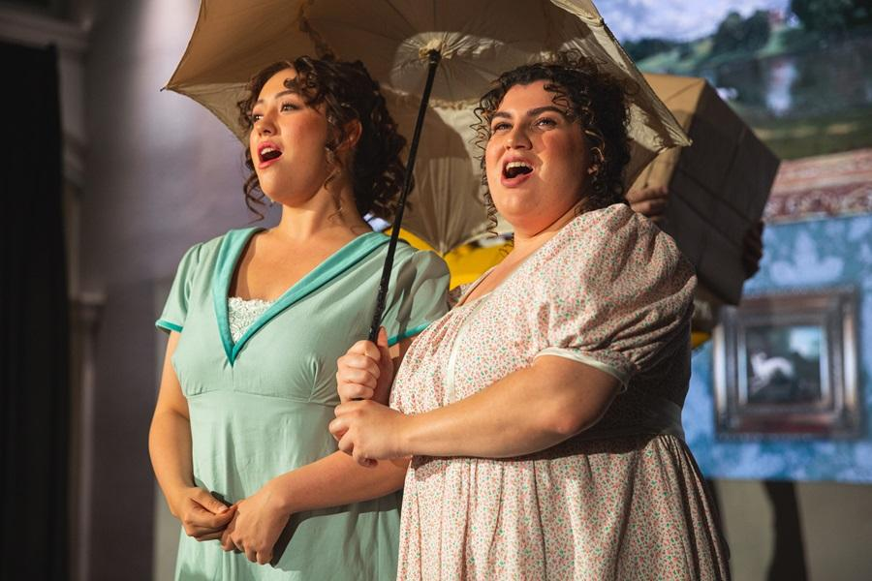

*credit Lewis Ferris*

**South Island Premiere: New Zealand Opera’s** [***Mansfield Park***](https://nzopera.com/opera/mansfieldpark/)**Returns This April**

**New Zealand, South Island -** After captivating audiences with sellout performances last year in Auckland and Wellington, NZ Opera now brings the acclaimed Waterperry Opera Festival production of *Mansfield Park* to Te Waipounamu. This enchanting chamber opera promises a stunning return season, delighting new audiences with its timeless charm.

“It is a delicious piece; a Regency drawing room intrigue, accompanied by the four able hands of pianists David Kelly and Soomin Kim, and a showcase for 10 singers”   
*- William Dart, NZ Herald, Mansfield Park 2024*

Based on Jane Austen's 1814 Regency-era novel, *Mansfield Park* vividly brings Austen's world to life. With music by celebrated 21st-century English composer Jonathan Dove and sung in English with a libretto by Alasdair Middleton, the production has earned international acclaim. Now, as New Zealand Opera stages it in Christchurch and at the Dunedin Arts Festival, South Island audiences can look forward to a captivating experience.

At the helm, acclaimed opera and movement director **Rebecca Meltzer** of Waterperry Opera Festival (UK) guides an outstanding all-New Zealand cast of singers..

"[Meltzer’s] joy-fuelled *Mansfield Park* sets a new benchmark of quality, vibrancy and sheer fun." - *Charlotte Valori, Bachtrack, Mansfield Park 2018 ★★★★★*

In the central role of quietly enchanting heroine Fanny Price, *Mansfield Park* features soprano **Michaela Cadwgan** (*Sweeney Todd,* *Parrawang Lifts the Sky, La rondine*). A rising star, Cadwgan made her NZ Opera debut in 2024 singing the role of Julia Bertram in the company’s first season of *Mansfield Park*, and has twice received the Victorian Opera Prize (2024, 2025). Her accolades also include winning the Wellington Regional Aria Competition, runner-up at the Lockwood New Zealand Aria, and awards such as the Saluzzo Opera Academy Scholarship, the Dame Sister Mary Leo Foundation Award, and the MOST Audience Prize at the 2023 IFAC Handa ASC Finals.

Seasoned New Zealand performers baritone **Robert Tucker** (*The Unruly Tourists, Eight Songs for a Mad King, Don Giovanni*), contralto **Kristin Darragh** (*Carmen, Madame Butterfly, Rape of Lucretia*) and soprano **Andrea Creighton** (*Le comte Ory, Der Rosenkavalier, Phantom of the Opera*) reprise their roles as Sir Thomas and Lady Bertram, and Aunt Norris respectively.

NZ Opera favourites **Joel Amosa, Joanna Foote**, **Andrew Grenon**, **Sarah Mileham** and **Taylor Wallbank** also return, bringing vocal mastery to their characters in this sparkling study of manners, marriage and money. London-based mezzo-soprano **Cecilia Zhang** joins the cast, returning home for her NZ Opera role debut after completing her masters degree with distinction at the Royal Academy of Music in London.

The story centers on Fanny, poor but pin-sharp and head over heels for her cousin Edmund. While Edmund, training to become a clergyman, is enchanted by their lively new neighbour Mary, her charismatic brother Henry turns his attention to Fanny. But can she trust his intentions?

While Austen’s signature wit shines throughout, Fanny’s understated grace comes to life not only through heartfelt arias and dialogues but also in the powerful eloquence of her silences—a true reflection of Georgian decorum.

Carrying the tale is Jonathan Dove’s elegant score, expertly performed by pianists **David Kelly** and **Soomin Kim** – four hands on one piano – in a chamber setting, seamlessly weaving into the era’s drawing room atmosphere.

A unique, immersive production, *Mansfield Park* offers a touching and emotive musical experience that Austen herself would have relished.

Tickets for the strictly limited South Island season are available now from [www.nzopera.com](http://www.nzopera.com)

**Ends**

**MEDIA CONTACT:**

For media information, images and interviews, please contact Kaiwhakahau,

Publicist Vanessa Preston, 021 217 3452 or vanessa@nzopera.co.nz

**IMAGES:** [**https://drive.google.com/drive/folders/15-0RXeytjwZPo9RtMhGj3PRANb1WSSPh?usp=sharing**](https://drive.google.com/drive/folders/15-0RXeytjwZPo9RtMhGj3PRANb1WSSPh?usp=sharing)

**Jane Austen’s MANSFIELD PARK**

Music by Jonathan Dove, libretto by Alasdair Middleton

A Waterperry Opera Festival production

**ŌTAUTAHI, CHRISTCHURCH**

1, 2, 3 April, 2025

The Great Hall at The Arts Centre

**ŌTEPOTI, DUNEDIN**

5, 6 April, 2025

Hanover Hall

As part of the Dunedin Arts Festival  


**TICKETS**

[**www.nzopera.com**](http://www.nzopera.com) **or ph 0800 696 737**

**Cast:**

Fanny Price: **Michaela Cadwgan**

Sir Thomas Bertram: **Robert Tucker**  
Lady Bertram: **Kristin Darragh**  
Julia Bertram: **Cecilia Zhang**  
Edmund Bertram: **Joel Amosa**  
Aunt Norris: **Andrea Creighton**  
Mary Crawford: **Joanna Foote**  
Mr Rushworth: **Andrew Grenon**  
Maria Bertram: **Sarah Mileham**  
Henry Crawford: **Taylor Wallbank**

**Creative team:**

Director: **Rebecca Meltzer**

Props & Costume: **Sophie Ham**

Pianists: **David Kelly and Soomin Kim**

**Notes to the Editor:**

[About Jonathan Dove](https://www.jonathandove.com/biography.html)

[About Alasdair Middleton](https://www.projectvocemoderna.com/creators/alasdair-middleton)

[About Rebecca Meltzer](http://www.rebeccameltzer.co.uk/about.html)

[About New Zealand Opera](https://nzopera.com/about-nz-opera/our-mission-values/)

