***The Paris Chamber Players***

New Zealand Tour Nov 2024

***After the Olympics, a French Cultural Marathon.***

Not to be outshone by the Olympian sportspeople, a group of Parisian musicians are embarking on a marathon tour around New Zealand: 14 concerts in just 18 days. A delightfully classical programme from the early 19th century, featuring the Beethoven Septet (7 players) and the Schubert Octet, (8 players) rarely presented together, and featuring instruments that almost make a mini orchestra, with violin, viola, cello, double bass, horn, bassoon and clarinet. And although most of the main centres are covered, the itinerary includes some of the cities that are not always on the main musical trunk line such as Paihia and Westport. The venues are also a bit of a highlight, including some of the lovely churches on the route such as Old St Pauls in Wellington and St Mary's in Auckland. Tickets will be on sale at the door if there are any left, otherwise, head now to Eventfinda.

<https://www.eventfinda.co.nz/tours-festivals/2024/paris-chamber-players-tour>

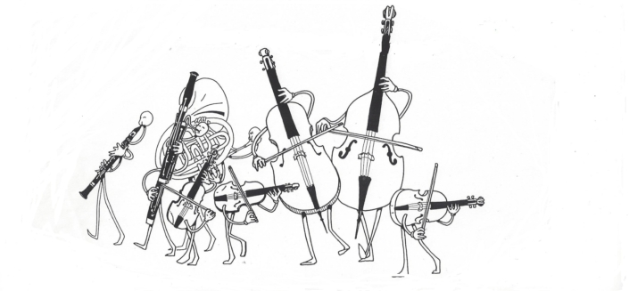

**The Musicians**

Born in Canteleu near Rouen, **Antoine Degremont** studied **Horn** in Rouen. Since his arrival in Paris, he has played regularly with the Orchestre National de France, the Orchestre de Paris and the Orchestre de l’Opéra de Paris. He was principal French Horn player with the Orchestre Symphonique Français before joining the Octuor de France.

**Cyril Garac** was born in Cannes (France) and received the First Prize from unanimous juries in both **Violin** and Chamber Music at the Conservatoire de Paris. Winner of several competitions, he continued to refine his playing under the guidance of some of the great French and international violinists and has collaborated in the creation & recording of many new works. An inquisitive approach has also led him to the world of tango music

For over 30 years **Bernard Lanaspèze** has been working with the largest orchestras in France (Orchestre de Paris, philharmonie de Radio France, Opéra de Lyon, Orchestre National des Pays de la Loire…) Open to all **Double Bass** repertoire his experience also covers contemporary (Ars nova, 2e2m), along with musical comedy, world music and in particular, Tango (quinteto El Después).

Born in Hiroshima, **Saori Kurimoto** began her studies of **Clarinet** in Japan and then came to France to further her studies at the École Normale de Musique in Paris, where she also studied composition. She combines orchestral and chamber playing with teaching around the French capital.

After studying violin and **Viola** with David Menzies and Mary O’Brien in Auckland (where he is from originally) **Mark Oremland** set off for Europe where he has played with numerous ensembles such as the Heidelberg Chamber Orchestra and smaller formations. He finally settled in Paris where he continues to follow his first love of chamber music, in parallel with working in the museum of languages he created.

Born in Valence in Drôme, **Vincent Reynaud** began his musical studiesof the **Bassoon** in his hometown, then continued studies at the National Regional Conservatory of Rueil-Malmaison. He entered the Conservatoire National Supérieur de Musique de Paris, where he obtained higher education degrees in bassoon and chamber music. Passionate about chamber music, he has spent many years with the Octuor de France in addition to numerous orchestras and other chamber ensembles.

Of Basque orgins, **Myriam Teillagorry** started the **Cello** in Bayonne and continued at the CNR in Paris and Boulogne Billancourt. She is an active member of the Orchestre Divertimento directed by Zahia Ziouani, known for its pedagogical work, bringing music to the wider public, including recently performances for the Olympics. She has played with many other orchestras and chamber ensembles, and in parallel teaches at two of the Paris regional conservatoires.

**Agnès Reverdy** began **Violin** at the age of 6 and continued at the conservatoire de Boulogne-Billancourt, along with chamber music studies. Her teachers included Ivry Gitlis. Today Agnès divides her time between her passion for teaching (at the conservatoire where she studied) symphonic music and chamber music, and also considerable involvement in festivals in France and overseas.