REMINDER - The 54th NATIONAL CONCERTO COMPETITION FINAL
Be part of the excitement as New Zealand’s next classical music star is born, right here in Christchurch.
On Saturday 19th June the National Concerto Competition Grand Final proudly returns to the fully-restored James Hay Theatre.
Experience a dazzling night of artistry as three exceptional young instrumentalists go head-to-head performing a solo concerto with Christchurch Symphony Orchestra conducted by Ken Young.
Who will win the career launching $10,000 first prize?
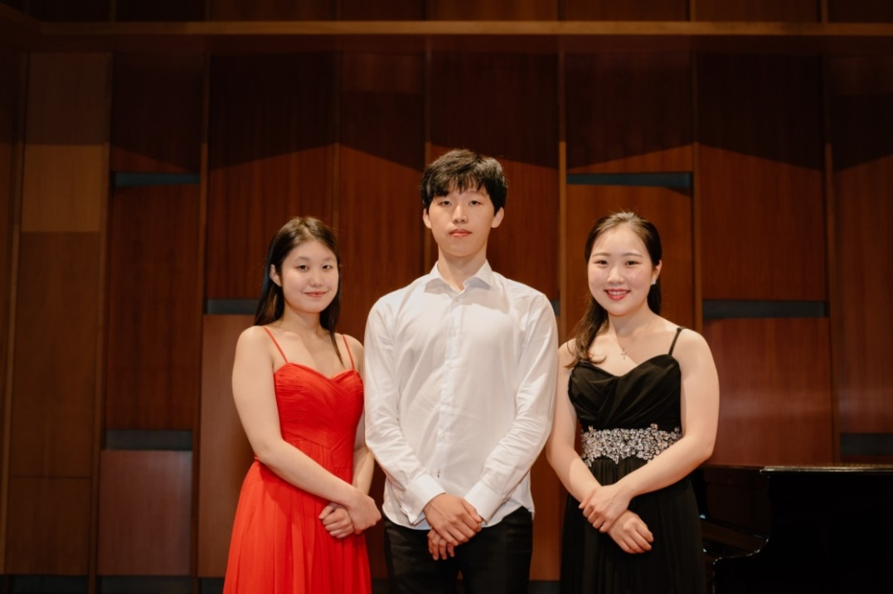

April Ju (Christchurch) “Violin Concerto in D minor, Op. 4” - Jean Sibelius
Hyein Kim (Auckland) “Sinfonia Concertante, Op. 125 (cello)” - Sergei Prokofiev

Catherine Kwak (Auckland) “Cello Concerto in B minor, Op. 104” - Antonin Dvorak

Book your tickets for 54th National Concerto Competition and get ready to be wowed.
Saturday 19 June | James Hay Theatre
BOOK NOW through Ticketek https://premier.ticketek.co.nz/shows/show.aspx?sh=CONCERTO21
or telephone 0800 842 538. * For Groups that are more than 6 people bookings can be made by telephone 379 0597 or email groups.aucklandNZ@ticketek.co.nz
There will be door sales on the night. These will be located in the Town Hall foyer from 6.30 p.m. (Please note: you are still required to pay a booking fee when purchasing door sales tickets).

