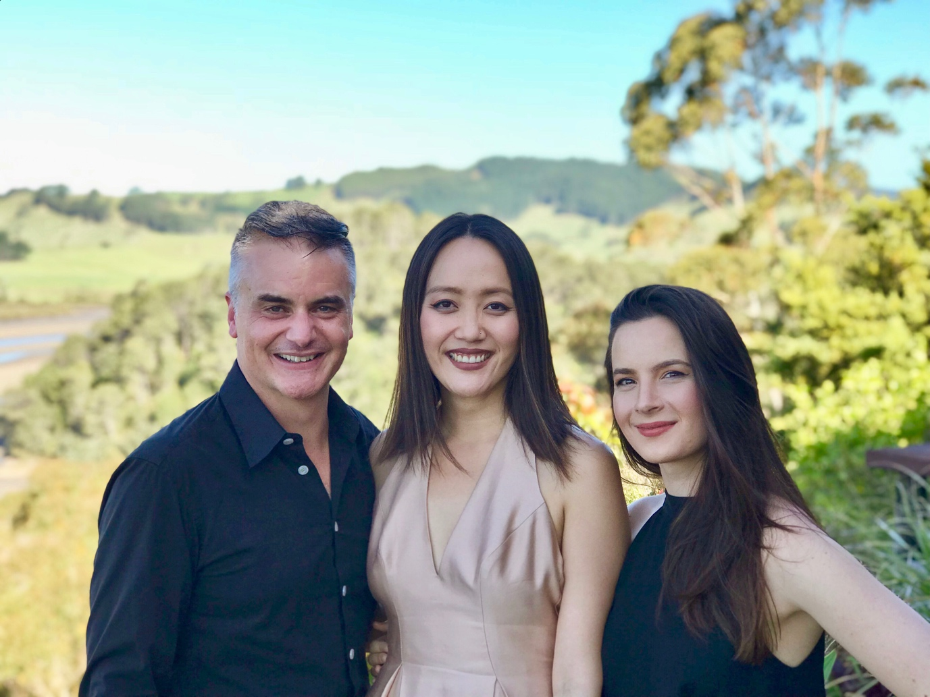
Ashley Brown (left), Somi Kim (centre), Amalia Hall (right)

Meet the new NZTrio!
Multi-awarding winning chamber ensemble NZTrio is thrilled to announce that founding member and cellist Ashley Brown will be joined by two extraordinary musicians, violinist Amalia Hall and pianist Somi Kim, as permanent members of the group. Amalia is an internationally acclaimed soloist and Concertmaster of Orchestra Wellington, and Somi is a versatile pianist based in London, in demand as a duo partner, and as an official pianist for many prestigious summer academies and international competitions in Europe.
Link to musician bios here

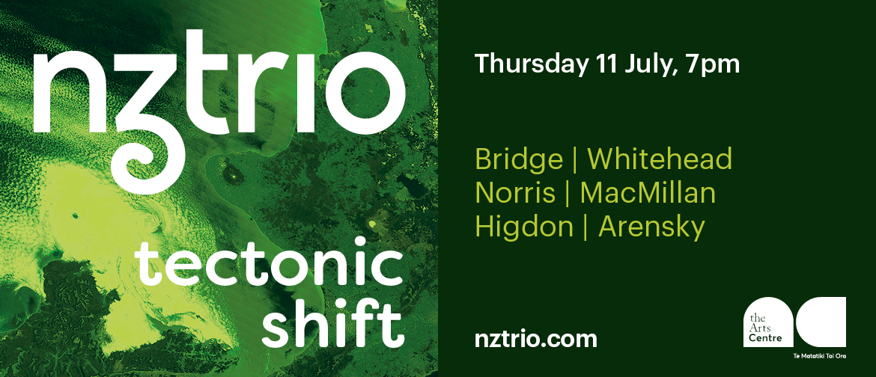
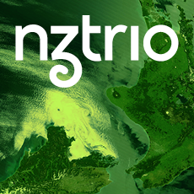

NZTrio: Tectonic Shift
The Arts Centre te Matatiki Toi Ora
2 Worcester Blvd, Christchurch Central
Thursday, July 11th - 7pm
Tickets $40 Adults / $30 TAC Friends / $20 Students
Tickets via Eventfinda – LINK:
https://www.eventfinda.co.nz/2019/nztrio-tectonic-shift/christchurch
Approx. 90 mins plus interval
Programme:

- Frank Bridge (UK) Allegretto
- Gillian Whitehead (NZ) Te waka o te rangi (NZTrio new commission)
- Frank Bridge (UK) Gavotte
- Michael Norris (NZ) dirty pixels
- James MacMillan (UK) Piano Trio No.2
*interval*
- Jennifer Higdon (USA) Pale Yellow and Fiery Red
- Anton Arensky (Russia) Piano Trio No.1 in d minor

Tectonic Shift sets sail aboard the Endeavour embarking on a huge voyage across oceans with the sounds of English parlour music in our ears - Bridge’s Allegretto - and arrive on these shores to the startling sounds of taonga pūoro. The music that follows is NZTrio’s very latest commission, from Dame Gillian Karawe Whitehead and is a melding of cultures that contemplates those first encounters between Māori and European through the lens of music - European instruments responding with open understanding and consideration to the uniquely Māori sounds that prevailed earlier. It’s a contemplation of worlds colliding.

